BÀI TẬP VỀ NUMPY

Import NumPy as np
In [1]:
​

Create an array of 10 zeros
In [2]:
​
Out[2]:
array([ 0., 0., 0., 0., 0., 0., 0., 0., 0., 0.])

Create an array of 10 ones
In [3]:
​
Out[3]:
array([ 1., 1., 1., 1., 1., 1., 1., 1., 1., 1.])

Create an array of 10 fives
In [4]:
​
Out[4]:
array([ 5., 5., 5., 5., 5., 5., 5., 5., 5., 5.])

Create an array of the integers from 10 to 50
In [5]:
​
Out[5]:
array([10, 11, 12, 13, 14, 15, 16, 17, 18, 19, 20, 21, 22, 23, 24, 25, 26,
27, 28, 29, 30, 31, 32, 33, 34, 35, 36, 37, 38, 39, 40, 41, 42, 43,
44, 45, 46, 47, 48, 49, 50])

Create an array of all the even integers from 10 to 50
In [6]:
​
Out[6]:
array([10, 12, 14, 16, 18, 20, 22, 24, 26, 28, 30, 32, 34, 36, 38, 40, 42,
44, 46, 48, 50])

Create a 3x3 matrix with values ranging from 0 to 8
In [7]:
​
Out[7]:
array([[0, 1, 2],
[3, 4, 5],
[6, 7, 8]])

Create a 3x3 identity matrix
In [8]:
​
Out[8]:
array([[ 1., 0., 0.],
[ 0., 1., 0.],
[ 0., 0., 1.]])

Use NumPy to generate a random number between 0 and 1
In [15]:
​
Out[15]:
array([ 0.42829726])

Use NumPy to generate an array of 25 random numbers sampled from a standard normal distribution
In [33]:
​
Out[33]:
array([ 1.32031013, 1.6798602 , -0.42985892, -1.53116655, 0.85753232,
0.87339938, 0.35668636, -1.47491157, 0.15349697, 0.99530727,
-0.94865451, -1.69174783, 1.57525349, -0.70615234, 0.10991879,
-0.49478947, 1.08279872, 0.76488333, -2.3039931 , 0.35401124,
-0.45454399, -0.64754649, -0.29391671, 0.02339861, 0.38272124])

Create the following matrix:
In [35]:
​
Out[35]:
array([[ 0.01, 0.02, 0.03, 0.04, 0.05, 0.06, 0.07, 0.08, 0.09, 0.1 ],
[ 0.11, 0.12, 0.13, 0.14, 0.15, 0.16, 0.17, 0.18, 0.19, 0.2 ],
[ 0.21, 0.22, 0.23, 0.24, 0.25, 0.26, 0.27, 0.28, 0.29, 0.3 ],
[ 0.31, 0.32, 0.33, 0.34, 0.35, 0.36, 0.37, 0.38, 0.39, 0.4 ],
[ 0.41, 0.42, 0.43, 0.44, 0.45, 0.46, 0.47, 0.48, 0.49, 0.5 ],
[ 0.51, 0.52, 0.53, 0.54, 0.55, 0.56, 0.57, 0.58, 0.59, 0.6 ],
[ 0.61, 0.62, 0.63, 0.64, 0.65, 0.66, 0.67, 0.68, 0.69, 0.7 ],
[ 0.71, 0.72, 0.73, 0.74, 0.75, 0.76, 0.77, 0.78, 0.79, 0.8 ],
[ 0.81, 0.82, 0.83, 0.84, 0.85, 0.86, 0.87, 0.88, 0.89, 0.9 ],
[ 0.91, 0.92, 0.93, 0.94, 0.95, 0.96, 0.97, 0.98, 0.99, 1. ]])

Create an array of 20 linearly spaced points between 0 and 1:
In [36]:
​
Out[36]:
array([ 0. , 0.05263158, 0.10526316, 0.15789474, 0.21052632,
0.26315789, 0.31578947, 0.36842105, 0.42105263, 0.47368421,
0.52631579, 0.57894737, 0.63157895, 0.68421053, 0.73684211,
0.78947368, 0.84210526, 0.89473684, 0.94736842, 1. ])

Numpy Indexing and Selection
Now you will be given a few matrices, and be asked to replicate the resulting matrix outputs:
In [38]:
mat = np.arange(1,26).reshape(5,5)
mat
Out[38]:
array([[ 1, 2, 3, 4, 5],
[ 6, 7, 8, 9, 10],
[11, 12, 13, 14, 15],
[16, 17, 18, 19, 20],
[21, 22, 23, 24, 25]])
In [39]:
# WRITE CODE HERE THAT REPRODUCES THE OUTPUT OF THE CELL BELOW
# BE CAREFUL NOT TO RUN THE CELL BELOW, OTHERWISE YOU WON'T
# BE ABLE TO SEE THE OUTPUT ANY MORE
In [40]:
​
Out[40]:
array([[12, 13, 14, 15],
[17, 18, 19, 20],
[22, 23, 24, 25]])
In [29]:
# WRITE CODE HERE THAT REPRODUCES THE OUTPUT OF THE CELL BELOW
# BE CAREFUL NOT TO RUN THE CELL BELOW, OTHERWISE YOU WON'T
# BE ABLE TO SEE THE OUTPUT ANY MORE
In [41]:
​
Out[41]:
20
In [30]:
# WRITE CODE HERE THAT REPRODUCES THE OUTPUT OF THE CELL BELOW
# BE CAREFUL NOT TO RUN THE CELL BELOW, OTHERWISE YOU WON'T
# BE ABLE TO SEE THE OUTPUT ANY MORE
In [42]:
​
Out[42]:
array([[ 2],
[ 7],
[12]])
In [31]:
# WRITE CODE HERE THAT REPRODUCES THE OUTPUT OF THE CELL BELOW
# BE CAREFUL NOT TO RUN THE CELL BELOW, OTHERWISE YOU WON'T
# BE ABLE TO SEE THE OUTPUT ANY MORE
In [46]:
​
Out[46]:
array([21, 22, 23, 24, 25])
In [32]:
# WRITE CODE HERE THAT REPRODUCES THE OUTPUT OF THE CELL BELOW
# BE CAREFUL NOT TO RUN THE CELL BELOW, OTHERWISE YOU WON'T
# BE ABLE TO SEE THE OUTPUT ANY MORE
In [49]:
​
Out[49]:
array([[16, 17, 18, 19, 20],
[21, 22, 23, 24, 25]])

Now do the following

Get the sum of all the values in mat
In [50]:
​
Out[50]:
325

Get the standard deviation of the values in mat
In [51]:
​
Out[51]:
7.2111025509279782

Get the sum of all the columns in mat
In [53]:
​
Out[53]:
array([55, 60, 65, 70, 75])

BÀI TẬP VỀ Matplotlib Exercises

Exercises
Follow the instructions to recreate the plots using this data:
Data
In [1]:
import numpy as np
x = np.arange(0,100)
y = x*2
z = x**2
** Import matplotlib.pyplot as plt and set %matplotlib inline if you are using the jupyter notebook. What command do you use if you aren't using the jupyter notebook?**
In [3]:
​

Exercise 1
** Follow along with these steps: **
- ** Create a figure object called fig using plt.figure() **
- ** Use add_axes to add an axis to the figure canvas at [0,0,1,1]. Call this new axis ax. **
- ** Plot (x,y) on that axes and set the labels and titles to match the plot below:**
In [4]:
​
Out[4]:
<matplotlib.text.Text at 0x111534c50>

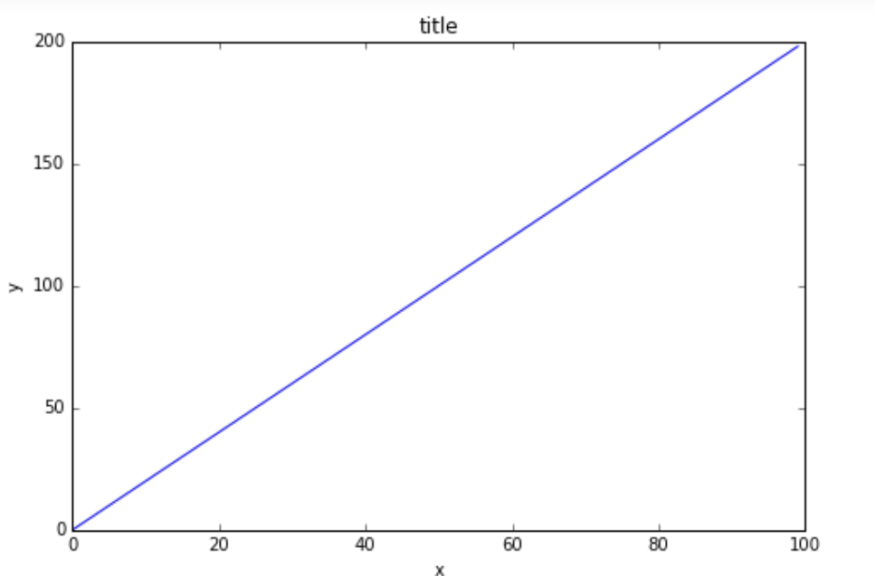Exercise 2
** Create a figure object and put two axes on it, ax1 and ax2. Located at [0,0,1,1] and [0.2,0.5,.2,.2] respectively.**
In [39]:
​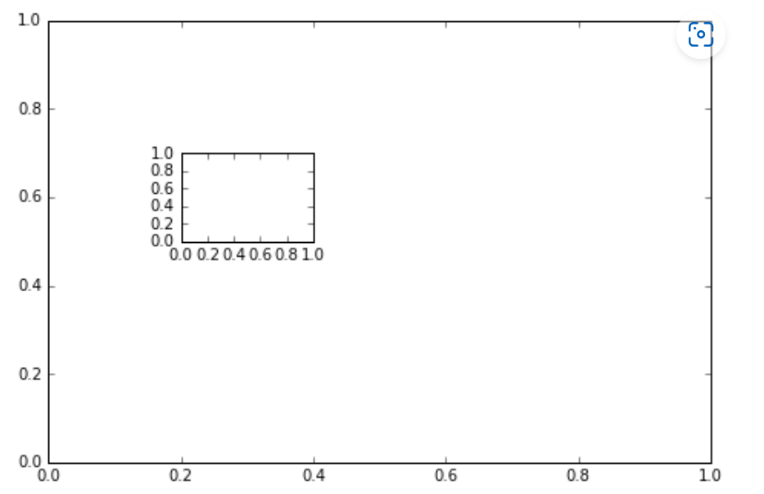

** Now plot (x,y) on both axes. And call your figure object to show it.**
In [42]:
​
Out[42]:
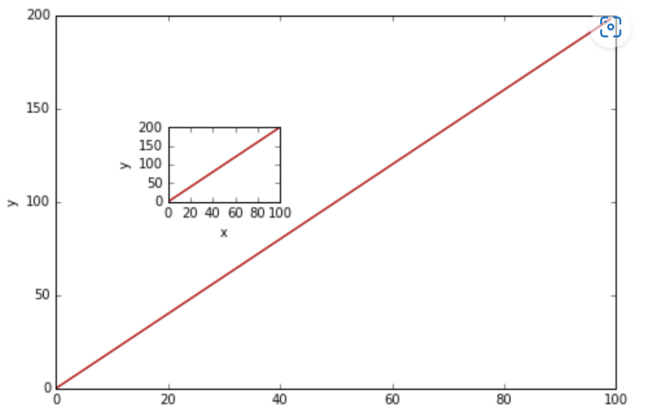

Exercise 3
** Create the plot below by adding two axes to a figure object at [0,0,1,1] and [0.2,0.5,.4,.4]**
In [6]:
​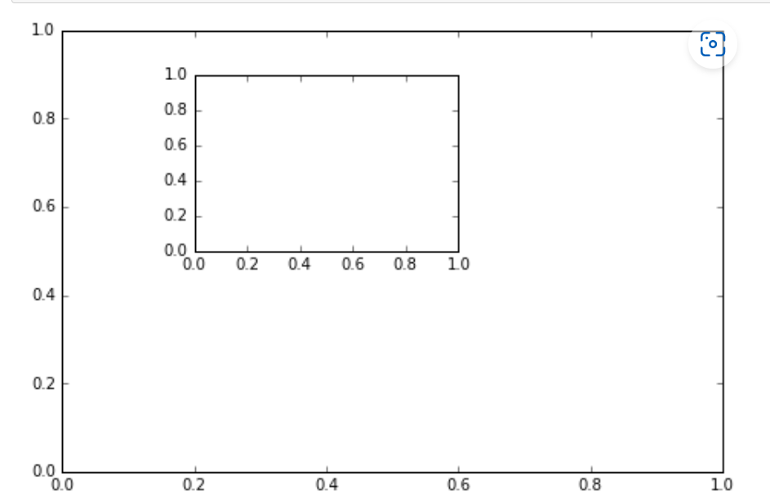

** Now use x,y, and z arrays to recreate the plot below. Notice the xlimits and y limits on the inserted plot:**
In [5]:
​
Out[5]:

